MASCHERPA Audric ROB 3 2022 / 2023

**POLY-SNAKE**

**Meeting report n°1 from 14/10/22 :**

Figure 1

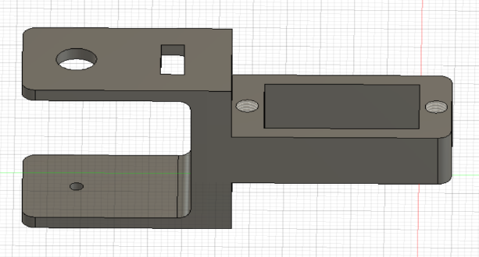

This first session was about the conception and the realization of the 3d printed piece who will make it possible to link the servomotors together.

Indeed, I was working on the conception of the main part of the piece during the first hour of the session and the figure 1 show what I produced:

Figure 2

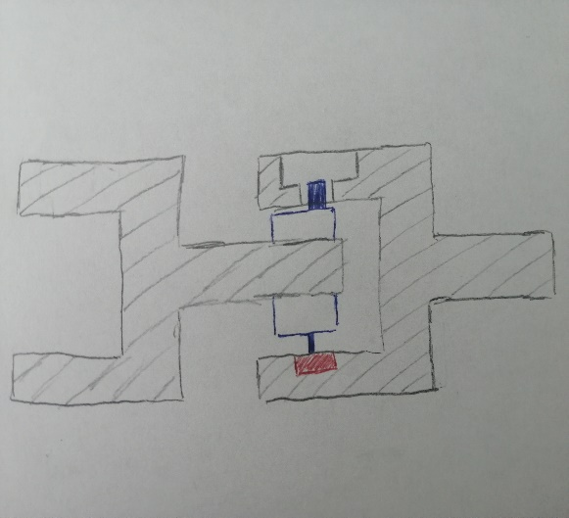Next, after talking with some of my teachers, I’ve decided to use ball bearings to hold in position the servomotor with the 3D printed piece and reduce friction as much as I can which will allow the snake to be more fluid in these movements. The figure 2 show a plan of the piece with servomotor in blue and ball bearing in red which was done in class.

Thus, it will me important to choose on the internet the more adapted ball bearing for the project.

Moreover, I decided during the last 2 hours to change the servomotors of the robot and to use the FS5109M one which is easier to found on the internet and has the same properties of the old one.

Finally, I also decided to realize the first concept of the 3D printed piece in wood to avoid having to print several 3D pieces and therefore waste time. Thus, the wood piece will allow me to find the best technical solution for the piece before 3D printing it.

The last hour was centered on the conception of the wood piece which should be finished the next session of the project. The website uses is <https://fr.makercase.com/#/>